Worksheet 16

GoverPod climbing Stairs

**Book Chapter**

**Learning Outcome 4**

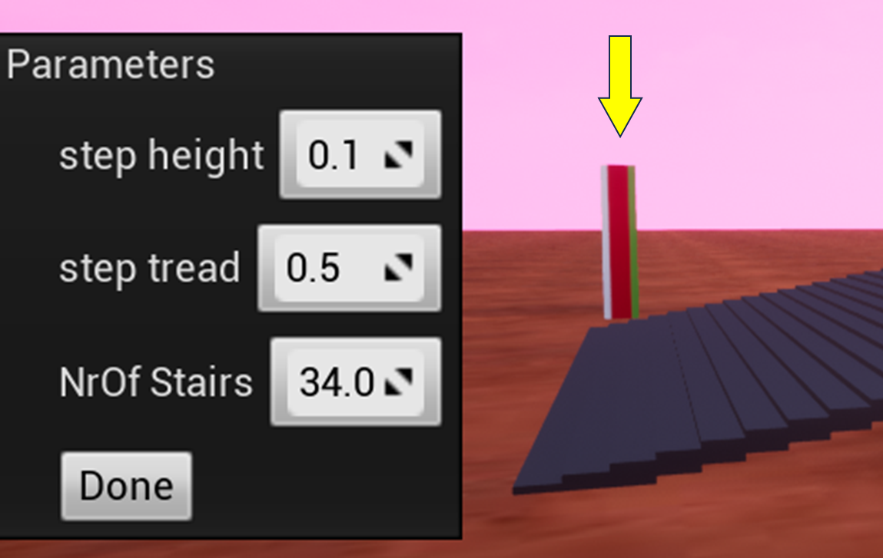

|  |
| --- |
| **1. Setting the Stairs Parameters**  Select the stairs by cross-hairing the column near the stairs then press **P** to get the parameter dialogue box shown on the right. The diagram below shows the meaning of the **step height** and **step tread**. The units are centimetres.  Also shown is how to calculate the slope angle of the stairs in radians. To get this into degrees, multiply by 180 and divide by pi. Note that if you double both height and tread, the angle will stay the same, so to get stairs of different angles, you will need only to change one parameter. |
| **2. How steep can the stairs become?**  Let’s investigate how the Pod with the tripot gait can cope with stairs.  (a) Select sensible values for the Pod’s parameters from your previous work.  (b) Start with a shallow slope angle and observe the Pod. Then increase the angle in stages. You could record its speed for each stage or just note when it fails to move.  (c) When the Pod fails to climb, then can you see what is causing the failure? |