Comp1421 Robot Design-Build-Test Project Brief and Report Template
Final Update 18-02-21
Here are the assessment guidelines
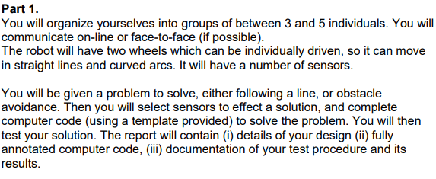
So you may choose one of the suggested problems below to solve. It makes sense to start with code you have used in the workshops and extend this (or combine various elements of code).
FREE CHOICE If you want to suggest a different project, that is fine. Please email me, or discuss in online chat, so I can check if your suggestion is feasible.

Straightforward DBT projects
Line-Following DBT
1) Create a track (perhaps like a Formula-1 track) and get the robot to follow this. Then slowly increase the robot’s speed and see how fast it can go before it loses the track.
2) Create a simple track with segments of several colors. Get the robot to follow this colorful track.
Obstacle Avoidance DBT
1) Extend the Finite State Machine to have more states producing a more complex behaviour. Start by designing the behaviour you want.
2) The parameters in the original FSM were set to avoid just a few obstacles. Consider an arena with a high density of obstacles. How would you tune the parameters to successfully navigate in such an arena?

More Challenging DBT Projects
1) Combine Braitenberg and Obstacle avoidance. The robot must move towards a light while avoiding obstacles in its path.
2) Combine Line following and obstacle avoidance. The robot must follow a line, but avoid any obstacles on the line.

How to Collaborate
Get together with at least two other students. Have a conversation with your team-mates and decide on a problem to solve, and decide how you will split the work across the team. Here is some guidance
1) Have a conversation about one or two (or more) ways to solve your chosen problem (in general terms, not yet specifics of coding.
2) Discuss the approach to coding, e.g., will you use a Finite State Machine, or an other approach
3) Create either/or (a) a flow diagram, (b) pseudo-code, (c) a FSM diagram
4) Either (a) work on the coding independently and compare the results of each other’s code (robot behaviour), (b) work on one piece of code together, here one team-member will take the lead, the other members will have a conversation with the lead coder who will explain the code, the others will ask critical questions.
5) Have a conversation about your testing strategy and decide on a strategy and carry it out.

Here’s a snip of the relevant assessment matrix.

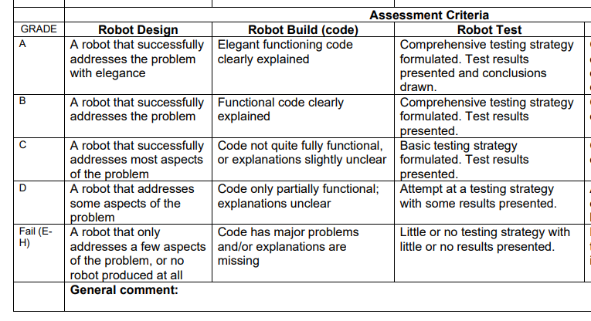
Comp 1421 Robot DBT Project (Assignment 3 – part 1)

Title | Name | Names of Team-mates

Final Update 18-02-21 (1) You may obtain maximum marks for a report of 1000 words but you will not be penalized for exceeding this ‘limit’ (ii) Your annotated code does not contribute to the word count (iii) you may include short movies of your solution, e.g. as YouTube clips (iv) You may email me a draft report for formative assessment (but only once).
Your report is an individual report which means it must be in your own words. You may share (i) code (but not annotated – annotations must be individual), (ii) images (iii) movie clips.

1. Short description of the Problem to be solved

State the problem, and briefly report on any discussions how you arrived at this problem.

2. The Design

Report on the design of your solution, including any flow-charts, pseudo-code or FSM diagrams. Report briefly on any significant discussions which led to this solution. You may mention alternative solutions discussed, and how your final approach was taken.

3. Annotated Code

Include here a full code listing, including line numbers. This code is likely to be the same for each team member. Then annotate your code AS AN INDIVIDUAL. You should explain (i) what the major blocks of code do (their goals and maybe sub-goals) (ii) details of all lines which are relevant to understanding how your solution works

4. Testing Strategy and Results

Report on any significant discussions that led to your test strategy. Then describe the strategy. Report on the test results and draw conclusions from these.

